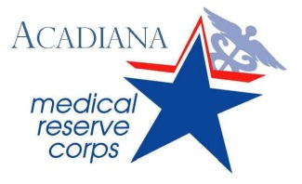

*Volunteers protecting Acadiana’s health and safety*

**ACADIANA MEDICAL RESERVE CORPS**

**AMRC, Frequently Asked Questions**

**What is the Acadiana Medical Reserve Corps?** The Acadiana Medical Reserve Corps (AMRC) is an organized group of medical and non medical volunteers who are trained to assist during times of emergency in our community. The AMRC was established in 2006 by the LA Emergency Medical Unit (LEMU) with support from the Lafayette Parish Medical Society. The AMRC now resides with the Acadiana Region Office of Public Health.

**Who is eligible to volunteer for the AMRC?** Any citizen that is 18 years of age or older may join the AMRC.  A wide range of medical professionals such as physicians, pharmacists, nurses, dentists, mental health providers and others are needed to provide direct medical services.  A large number of non-medical volunteers are also needed to provide support services ranging from clerical and computer support to transportation and communications.

**What are the benefits of volunteering for the AMRC?**By volunteering for the AMRC you will become part of a volunteer organization working to ensure that our community is as prepared as possible for responding to large scale events.  By volunteering prior to an emergency, you will be trained and provided credentials that allow you to be quickly and effectively deployed.

**What might I be asked to do?** Volunteers may be called to assist in the response to local emergencies; examples include responding to Hurricanes, Floods, Public Health Outbreaks and Acts of Terrorism. Specific responses may involve the distribution of medication or vaccines at mass distribution sites called *Points of Dispensing Sites (PODS)* or staffing *Medical Special Needs Shelters* or *Triage Sites* following a storm that has impacted Acadiana. Volunteers may even be called to assist in organizing additional volunteers that respond to help at the time of an emergency.  Volunteers will not be asked to do things that they are not trained for or comfortable doing.  There are tasks for anyone willing to help.

**How do I join the AMRC?** Registering for the AMRC takes less than 10 minutes. Simply log onto [www.lava.dhh.louisiana.gov](http://www.lava.dhh.louisiana.gov) and click *Register Now*. If interested in receiving text messages, be sure to click *Add an Additional Contact Method* and select *SMS/Text Message* then list cell number again. Current AMRC members can update their profile using these same steps in order to receive text messages.

**How would I be notified if the AMRC were to be activated?** Once you join, your name will be entered in the State of Louisiana’s Volunteer Database, *LA Volunteers in Action (LAVA)*.  If an event requires the call-out of the AMRC volunteers, you will receive notification informing you of the incident and requesting your assistance.  If you are able to respond you will be asked to go to a centralized staging location for detailed information and deployment instructions. You will never be sent into an unsafe area.

***Please be sure to check junk/spam folders for notices sent by AMRC/LAVA.***

FEMA ICS-100.B

Introduction to Incident Command System (ICS)

FEMA ICS-700.A

National Incident Management System (NIMS)-An Introduction

To access these courses, log on to: <http://training.fema.gov/IS/NIMS.asp>.

Scroll down the available courses and click the link to the corresponding course. To the right of the page, click *interactive web-based course* to begin.

Suggested Trainings:

**The AMRC, Office of Public Health and the Lafayette & Acadia Parish Sheriff Offices hosted Self Defense Courses in the fall of 2011.**

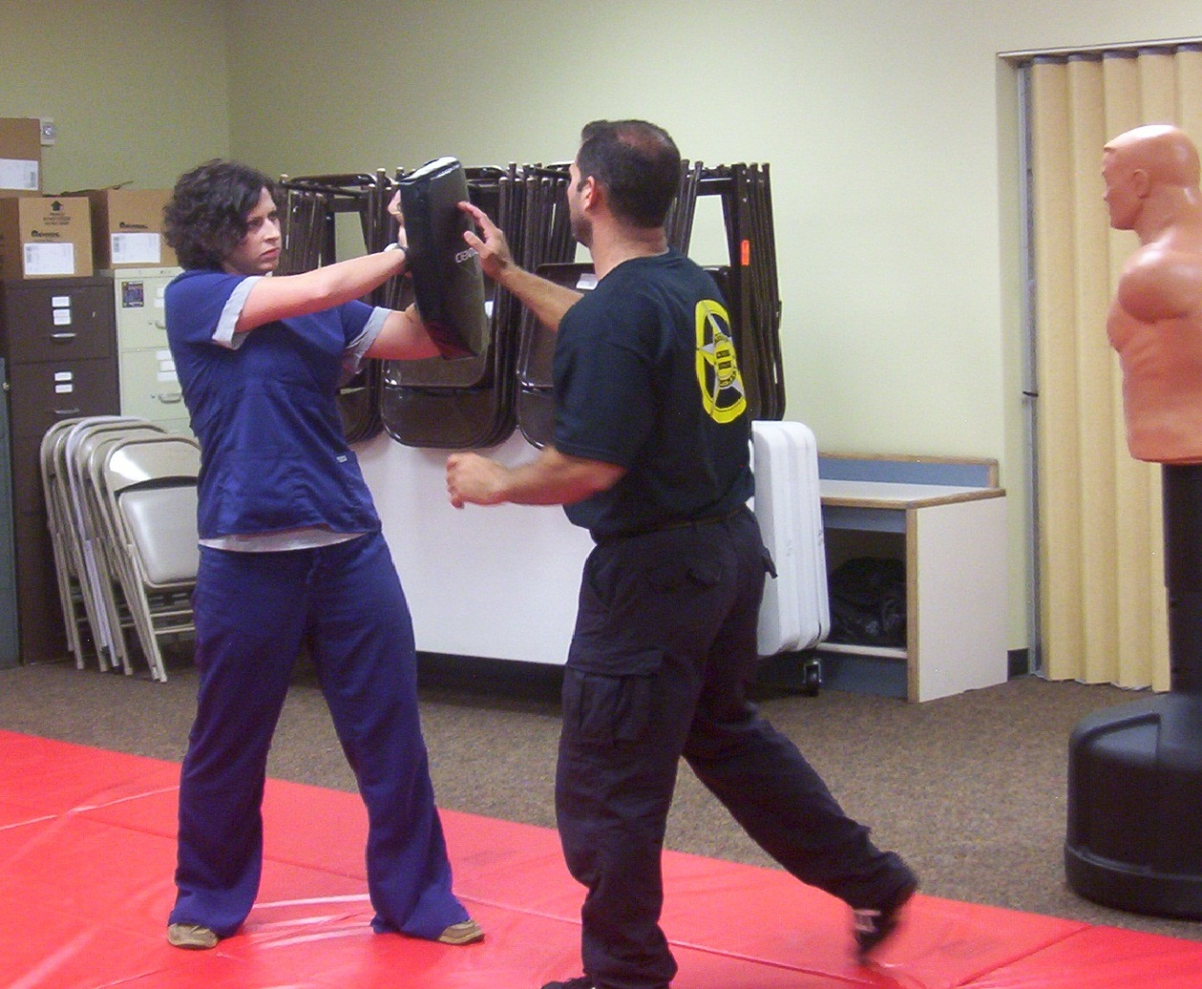

Volume 1, Issue 1

December 2011

ACADIANA MEDICAL RESERVE CORPS (AMRC)

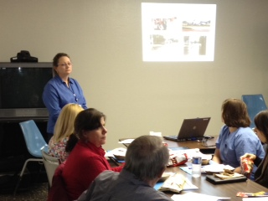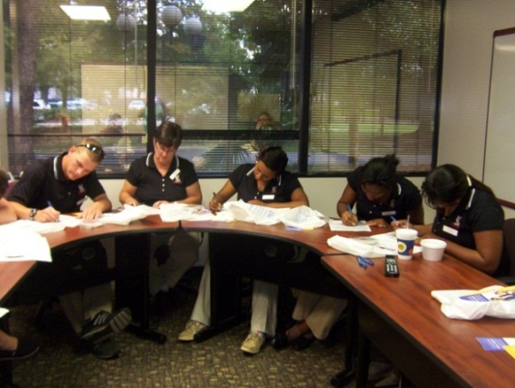

***Volunteers and community partners participated in a Points of Dispensing Training conducted by Office of Public Health Staff in November, 2011.***

Volunteer Opportunity: Points of Dispensing Sites (PODs)

In the event of a biological or other hazardous agent incident where large numbers of the population are exposed, mass dispensing of medication/vaccinations could be required. Mass dispensing of medication/vaccinations is complex, challenging, and must be accomplished rapidly during a public health emergency. **Point of Dispensing Sites (PODs)** are locations, usually large public buildings, where a large number of people may receive medication or vaccine. PODs are designed to quickly and accurately dispense medicines and/or vaccines to well individuals or to an exposed population to prevent illness. These are not clinics or places to receive extensive medical evaluation.

AMRC volunteers may be contacted by their parish Office of Homeland Security and Emergency Preparedness directors for assistance with POD planning in their local community. AMRC volunteers can offer their knowledge and experiences to help create the best plan for their parish.

Acadiana Medical Reserve Corps

Jennifer S. Doucet, AMRC Unit Coordinator

825 Kaliste Saloom Road, Brandywine 3, Suite 100

Lafayette Louisiana 70508

(337) 262-5644

**UL Lafayette nursing students visit the OPH Regional Office for an Introduction to Public Health course. During the course, they are briefed on the Acadiana Medical Reserve Corps and students are seen here completing volunteer application forms to become members of the AMRC.**

Mass Prophylaxis Training and Tabletop Exercise

February 7th & 8th, 2012

8:00 am - 4:30 pm

Abdalla Hall

635 Cajundome Boulevard

Lafayette Louisiana 70506

If interested, please contact:

Carol Broussard, RN

337-262-1658

carol.broussard@la.gov

Upcoming Training



www.lava.dhh.louisiana.gov